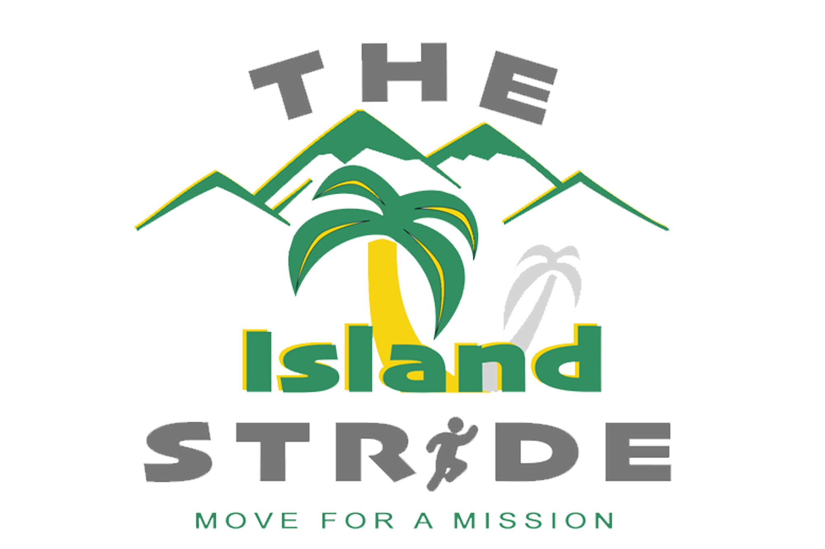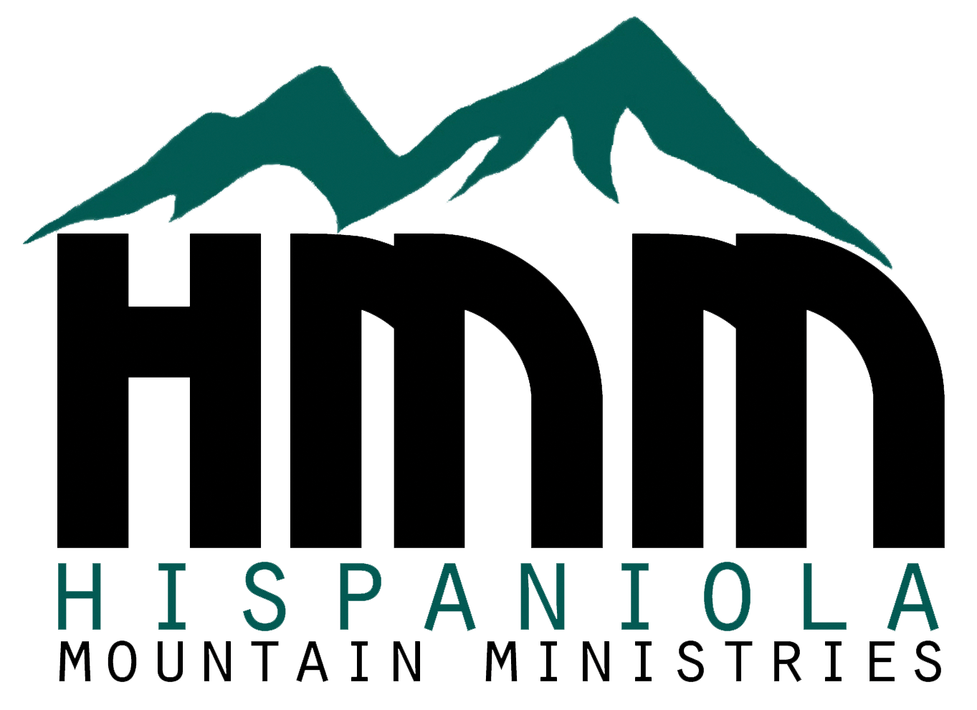

Dear Friend,

On March 5th, I am participating in Hispaniola Mountain Ministries (HMM) Island Stride event. HMM is a ministry focused on patterning with local, indigenous churches in the Dominican Republic and Haiti. They compassionately serve alongside the local pastors and churches to minister to the needs of their communities and to share the LOVE of Jesus Christ. Everything they do is through the local churches and is for encouraging, equipping, and empowering the people of those countries. I am participating so HMM can continue to minister with these churches and support the ongoing ministry on the ground.

HMM ministers in many ways:

• monthly support to pastors

• supports Haitian school including providing the teachers salaries

• child and widow sponsorships

• helps feed over 5000 people daily

• training of church in intentional, strategic, progressive discipleship

• pastor training - helping pastors earn a Certificate of Pastoral Ministries from seminary

• and so much MORE!

For more information, please visit their website at www.gohmm.org.

I am writing to invite you to sponsor me. My goal is to raise **[your goal amount]***.* Will you help? The donation amount is not a per-mile pledge, but rather a one-time donation. Some sponsors give $100, some $25, others $10. Your gift is tax-deductible and any amount impacts lives!

Thank you for supporting me as I put my feet into action on Saturday, March 5th, making a difference in so many lives in Haiti and the Dominican Republic.

Thank you,

[**Your Name, phone # and email**]

[**Your personal fundraising page link**]

**SPONSOR REQUEST LETTER / EMAIL**